| Ousmane Toure & Jianning Chen  EECE 2160 | Embedded Design: Enabling Robotics  Lab Assignment 2 |
| --- | --- |

Lab Assignment 2

Ousmane Toure & Jianning Chen

Toure.o@northeastern.edu

chen.jiann@northeastern.edu

Submit date: 5/19/2022

Due Date: 5/20/2022

**2.0 Code/Schematics**

* Schematic for 2.1

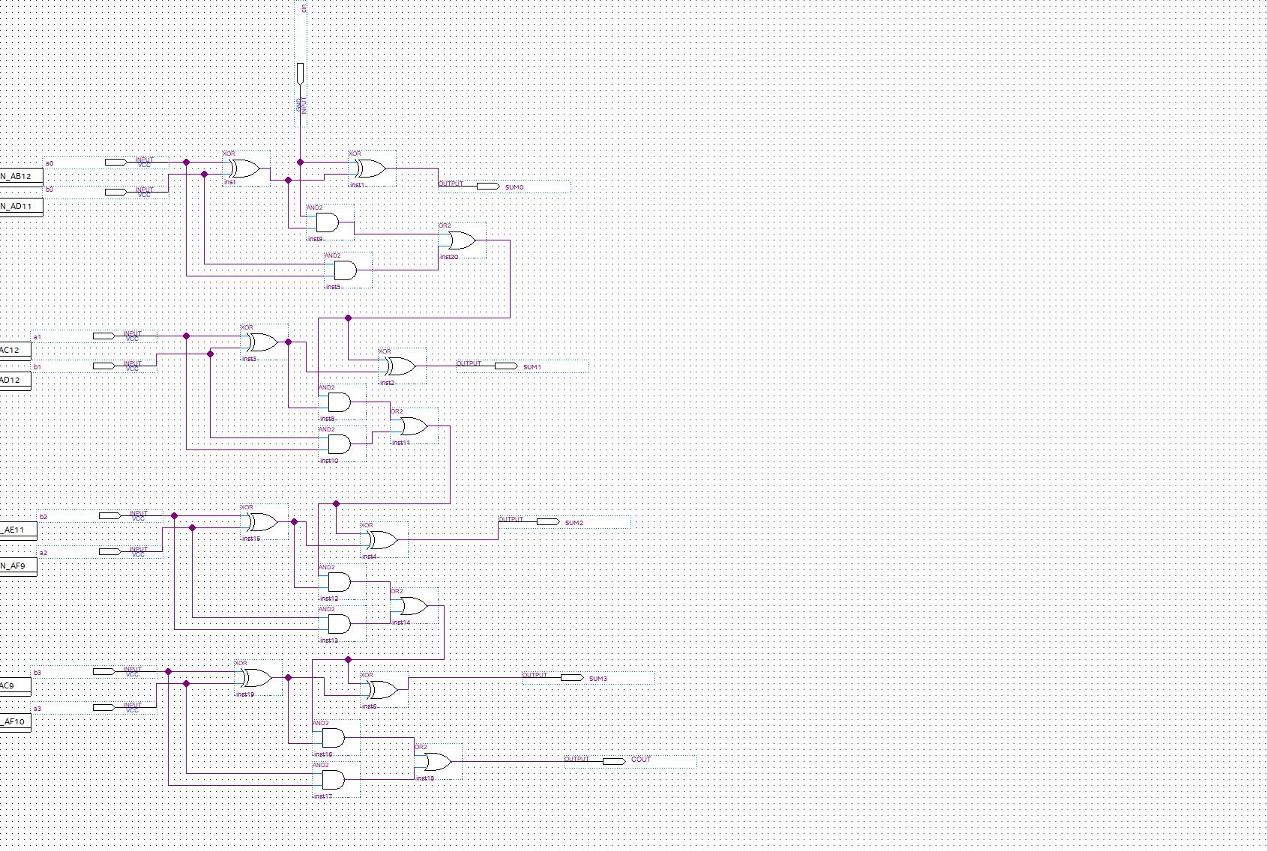

* Schematic for 2.2

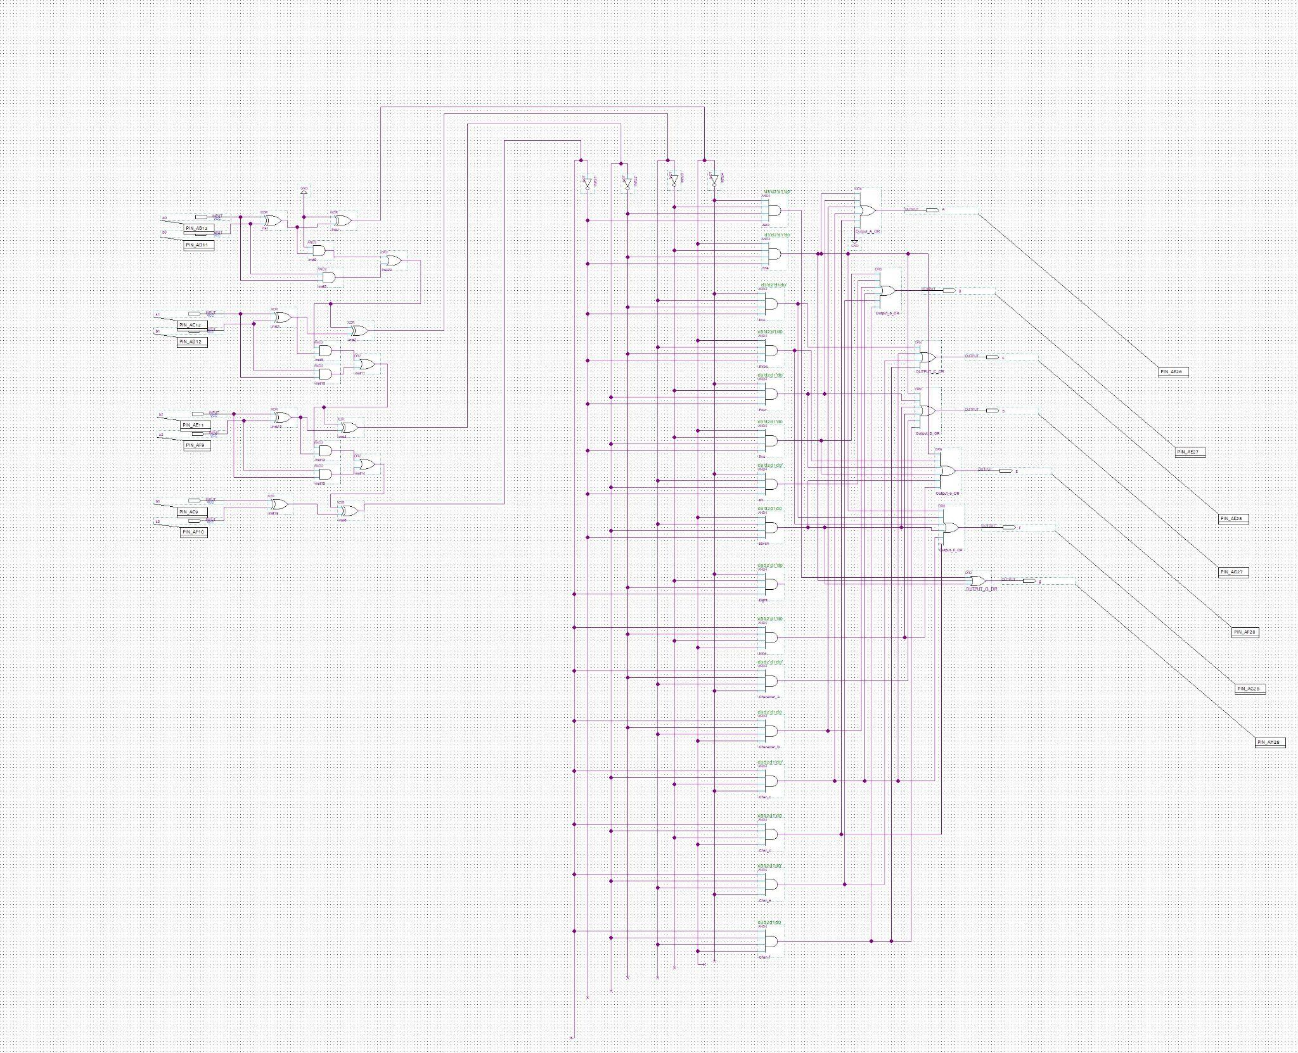

* The left part of schematic of 2.2 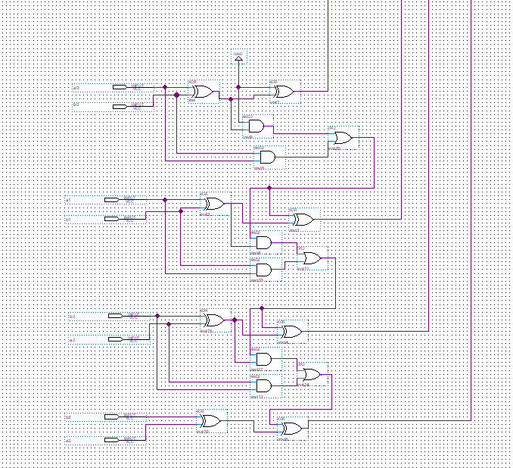
* Schematic for 2.3

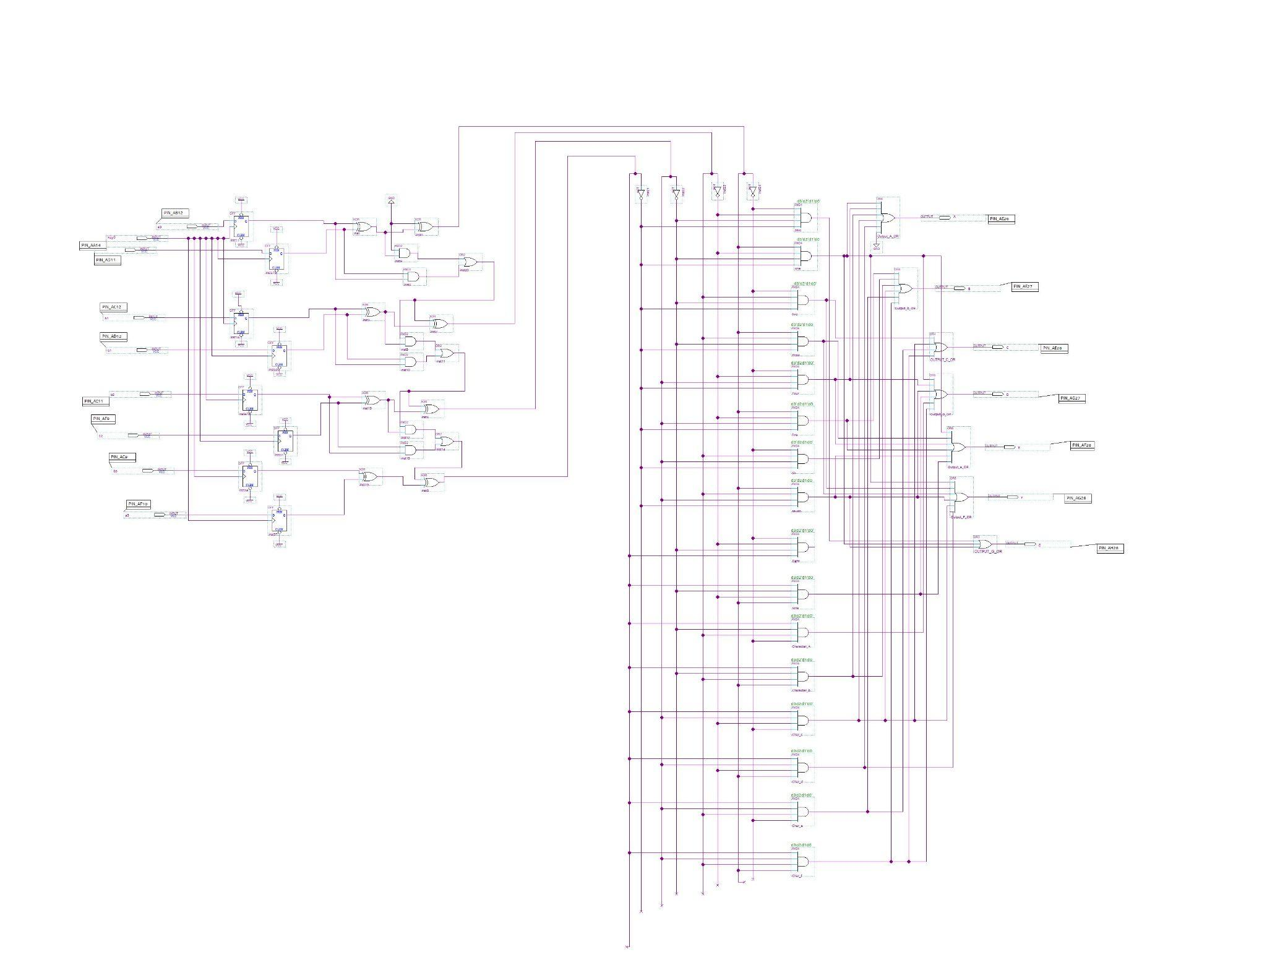

* The left part of schematic of 2.3

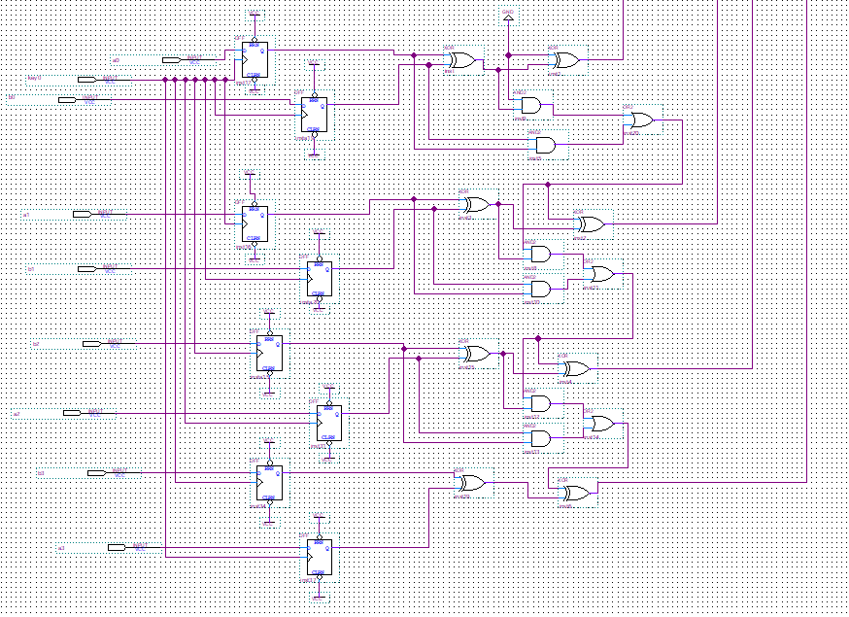

**2.1 Section 1 of Lab 2**

Section 2.1 of Lab 2 consisted of creating a 4 bit full adder using logic gates. The logic of the circuit is as follows: 8 switches are the input numbers (SW3 to SW0 is a number and SW7 to SW4 is another number). Turning the switch on means 1 for that digit and off indicating 0 for that digit. The LED are the outputs showing the sum of two binary numbers added together.

We were able to accomplish this by using ground as our cin as annotated in our schematic. We then utilized two XOR gates, two AND gates and one OR gate to complete each section.

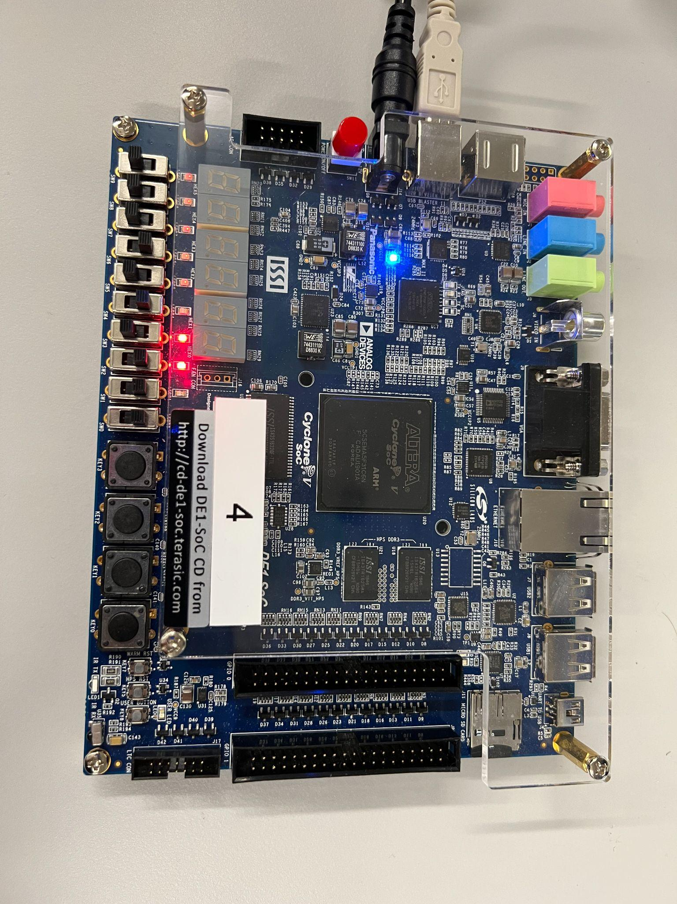

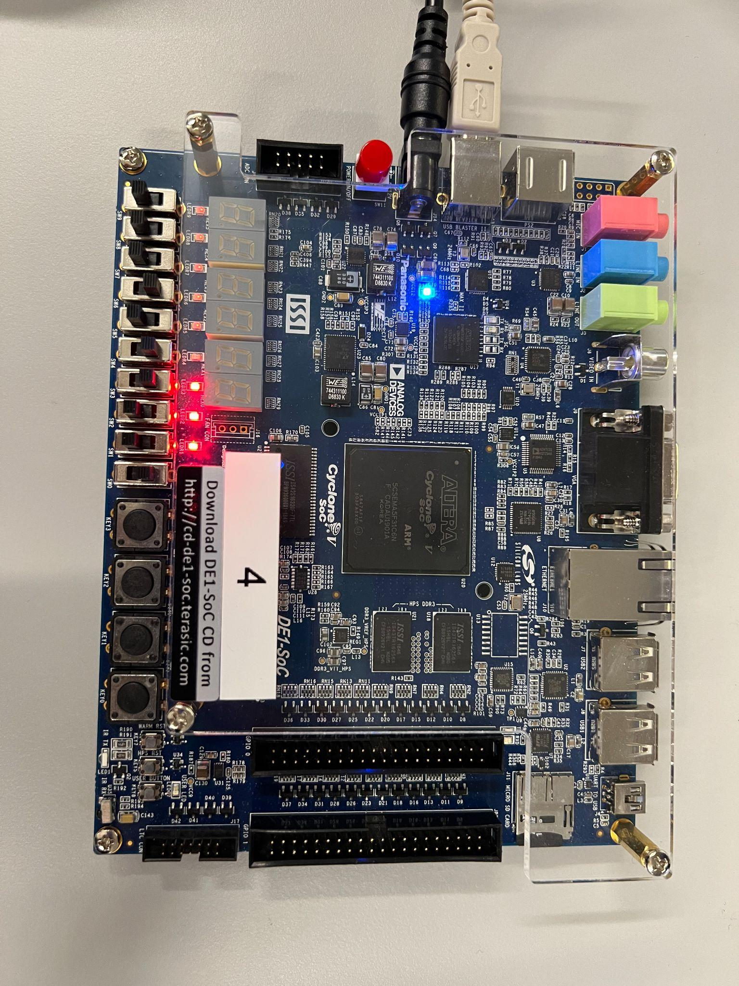

**2.2 Section 2 of Lab 2**

For the second part of the lab, the goal is to assign the sum to one of the 7-segment display, which means the carry-out bit will be discarded. Therefore, some modifications have to be made in order to adjust for the missing carry-out bit, which includes deleting the wires, two AND gates and one OR gate that are linked to COUT in the circuit in the previous section.

In the previous lab, the 7-segment display takes in 4 inputs: D0, D1, D2, D3. In this section, SUM3 is linked to D3, SUM2 is linked to D2, SUM1 is linked to D1 and SUM0 is linked to D0. After the output pin is assigned, the output shows in the following pictures.

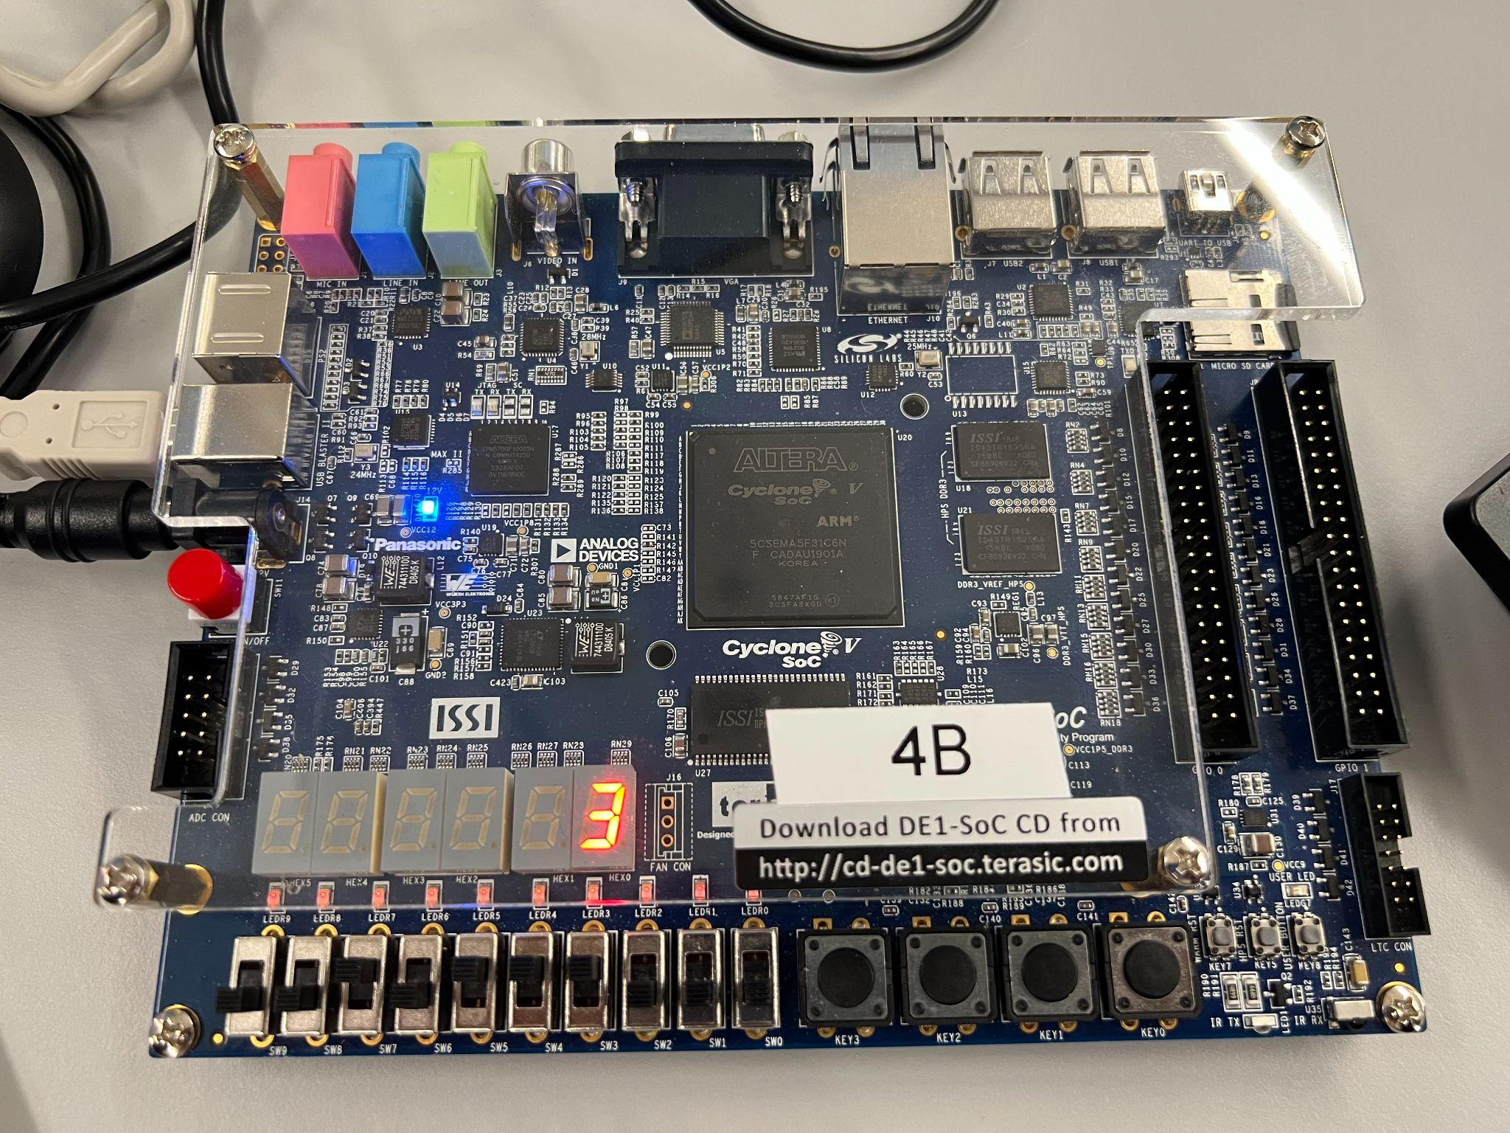

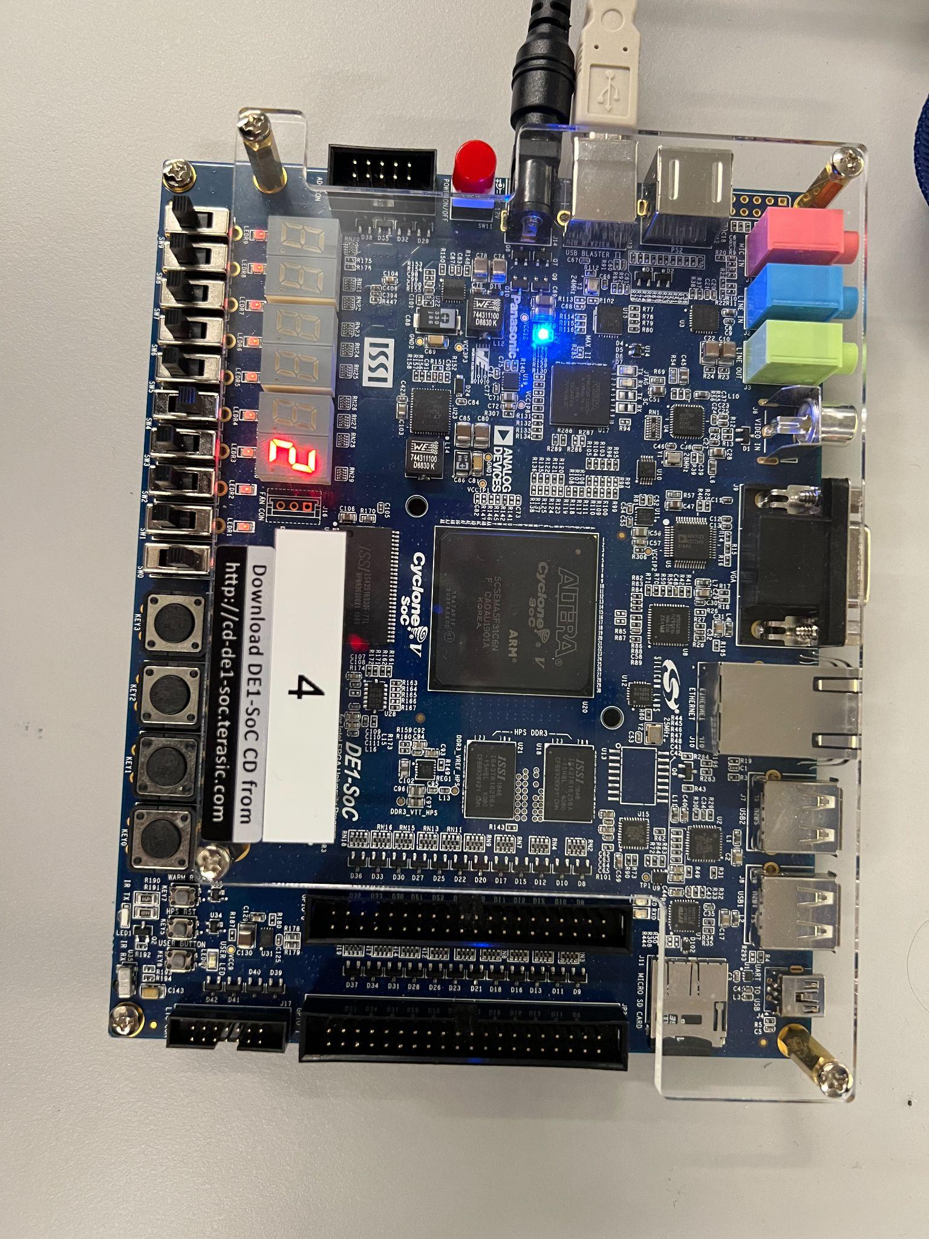

**2.3 Section 3 of Lab 2**

Section 3 of lab 2 consisted of adding a clock to 2.2 by utilizing a D flip flop or DFF. This was completed by adding a DFF to each individual toggle switch. A DFF works by saving the edge input of the clock, and delays the output signal until the next clock signal occurs. The clock is controlled by a button which in this section is controlled by pressing “Key0” on the board. When connected to our 7 segment display, we were able to keep the LED value displayed even after the switches were changed as documented in our figures below. The following pictures are showing the process of how D flip-flop works: The first picture is showing 1001+0110, which the 7-segment display is supposed to show “F”. The second picture shows that the 7-segment display is still showing “0” and “Key0” will be pressed. The third picture shows that after the button is pressed, the clock is enabled and the result shows up as an “F”.

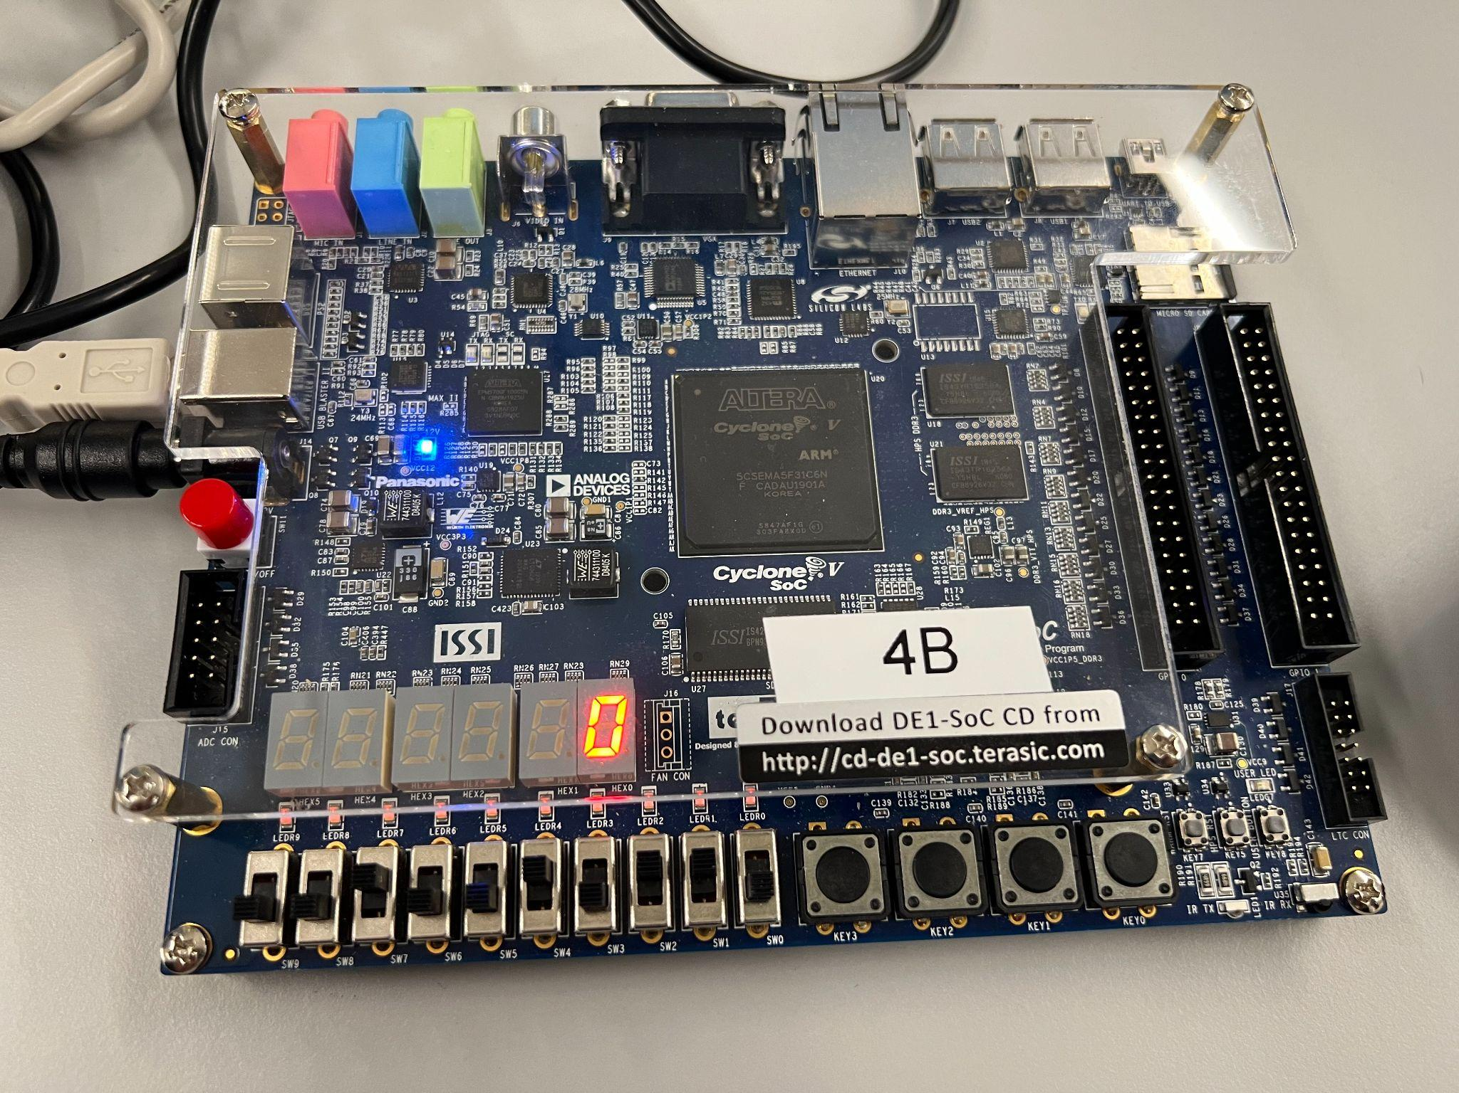

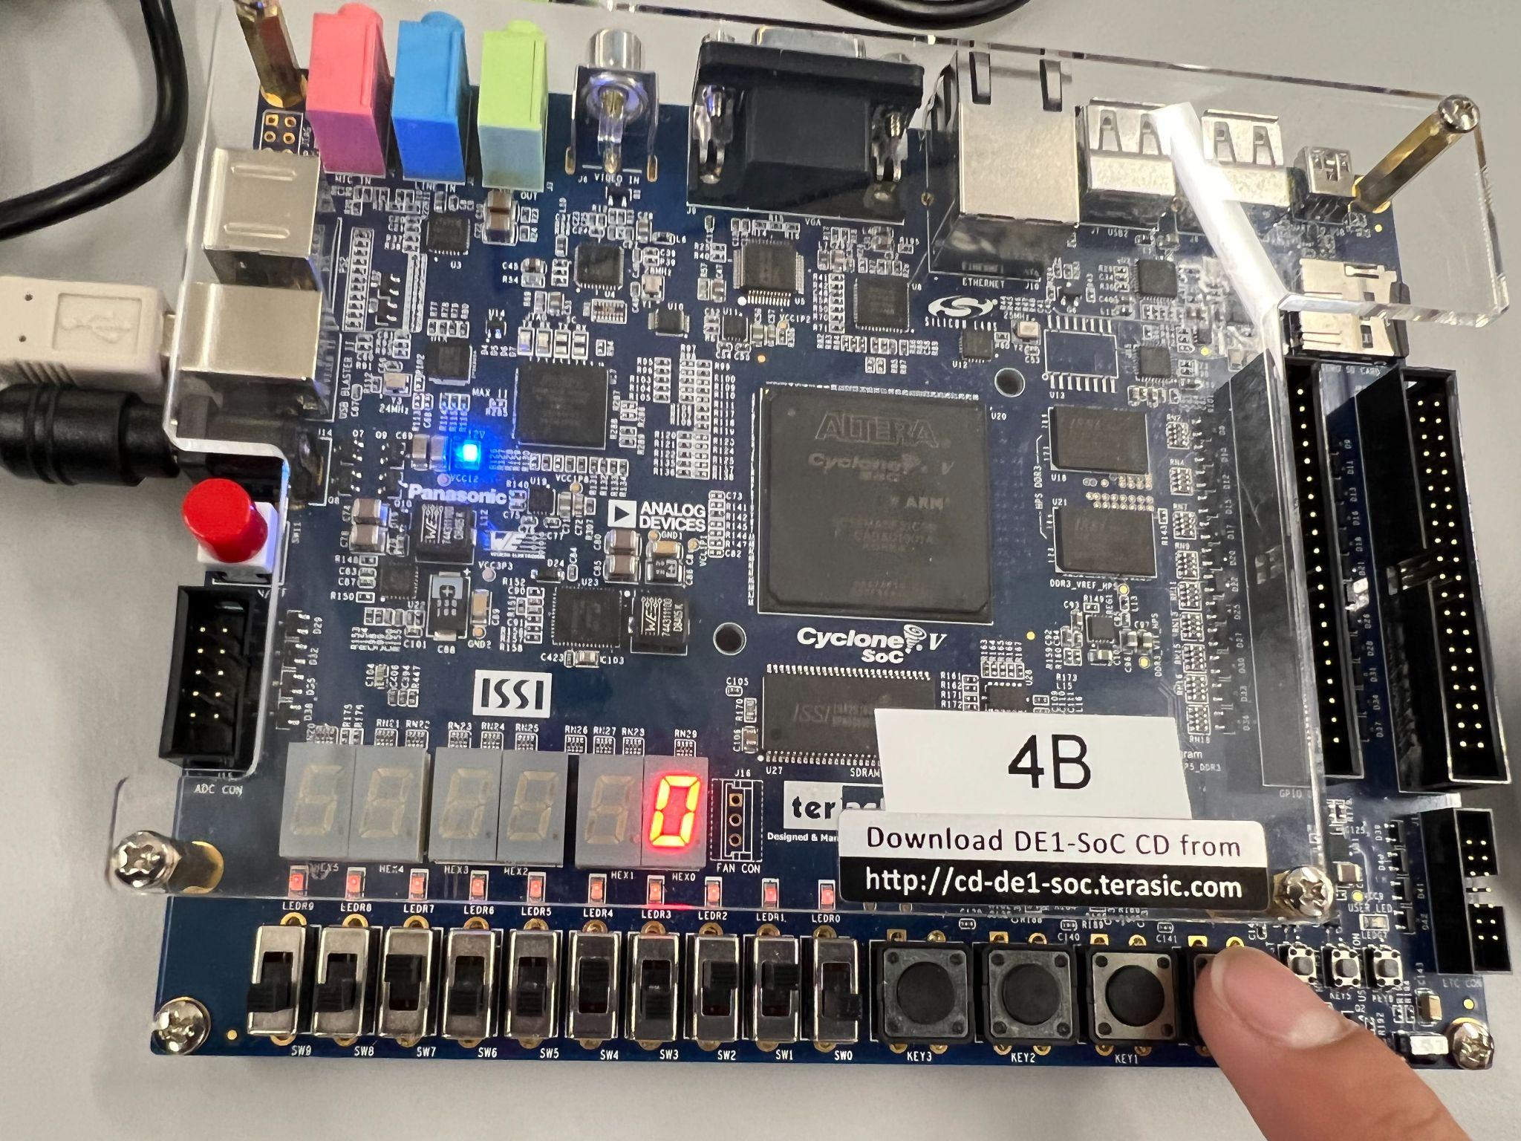

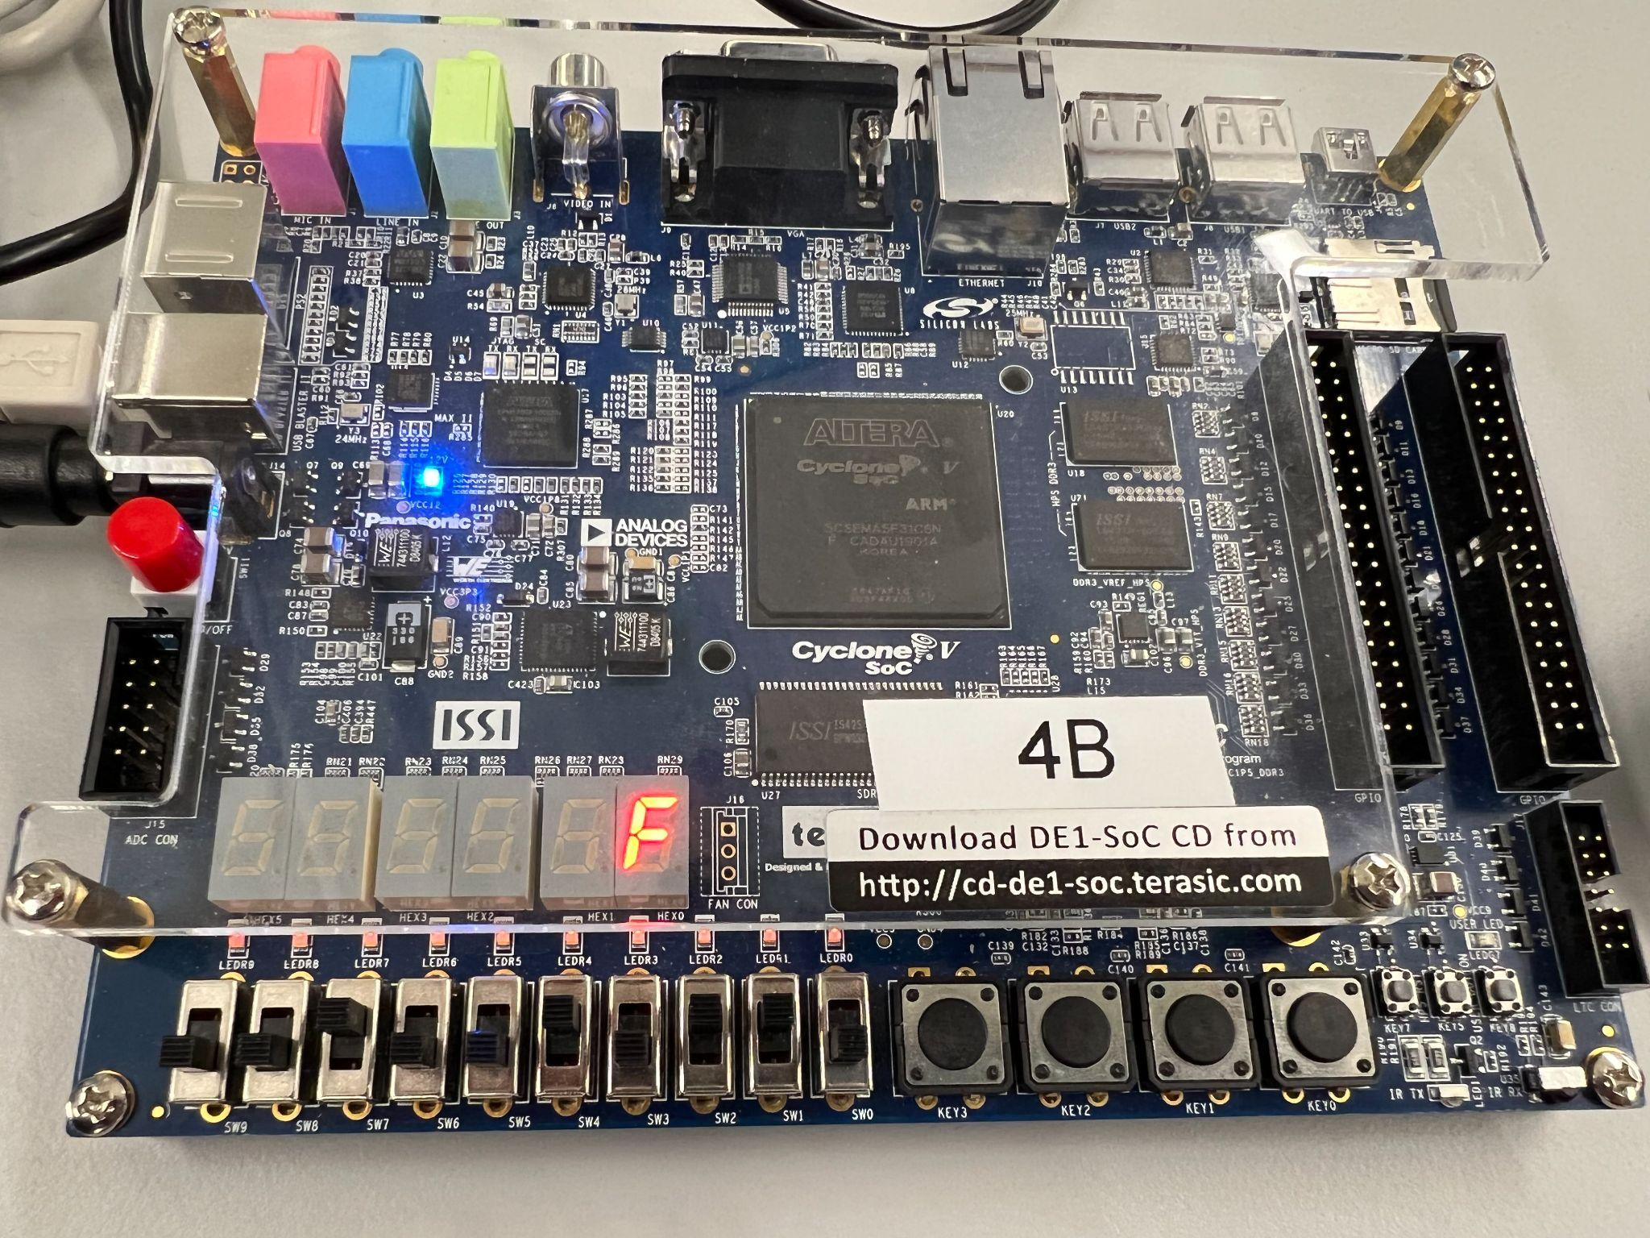

# References

1. Prof. Julius Marpaung, “*Lab Report Guide*”, Northeastern University, January 6 2020.
2. Terasic, DE1-Soc Manual, User Manual”,January 28, 2019